**OFFICIAL COORDINATION REQUEST FOR**

**NON-ROUTINE OPERATIONS AND MAINTENANCE**

**COORDINATION TITLE- 22BON004 MOC T12 Outage**

**COORDINATION DATE- 9 March 2022**

**PROJECT- Bonneville Lock & Dam**

**RESPONSE DATE- 23 March 2022**

**Description of the problem:**

Bonneville Lock & Dam’s Powerhouse Two (PH2) requires regularly planned T12 (U15-18) transformer maintenance. This work will be started on 29 August and continue through 15 September 2022. This work will require Units 15, 16, 17, and 18 to remain Out of Service (OOS) for the duration of work.

This outage has been coordinated for the timeframe of 29 August to 15 September with the intention of minimizing impacts on fish (**Tables 1, 2, and 3**), unit priority order, and spill. (**Figures 1 and 2**).

**Type of outage required:** The T12 outage will take four units (U15-18) OOS.

**Impact on facility operation** (FPP deviations): This operation requires the outage of Units 15-18. During the specified dates, the Washington Shore Fishway ladder will remain within FPP operation criteria. Unit priority will shift from FPP guidance. Spill may be used if the remaining PH2 units and PH1 units reach max capacity. The spillway and Powerhouse Two Corner Collector (B2CC) will remain in service according to FPP guidance for summer spill through 31 August. After 31 August, spill may be implemented for excess flow, in which case the B2CC will be opened in accordance with the FPP (BON 2.2.2).

**Impact on unit priority:** Starting 29 August, unit priority will be impacted due to the T12 outage:

Current FPP Unit Priority Order Criteria (BON 4.1, Table BON-13):

PH2: 11, 18, 12, 17, 13, 14, 15, 16

PH1: 1, 10, 3, 6, 9, 4, 5, 8, 7, 2

During T12 Outage:

PH2: 11, 12, 13, 14

PH1: 1, 10, 3, 6, 9, 4, 5, 8, 7, 2

**Impact on forebay/tailwater operation:** None

**Impact on spill:** The spillway will remain in service through 31 August, per FPP summer spill criteria. Beginning 01 September, the spillway will remain available for use. If a high flow event occurs, Units 11-14 and 1-10 will be available for use. If these units do not accommodate the flow volume, spill may be initiated, at which time the B2CC will also be opened.

**Dates of impacts/repairs:** 29 August to 15 September

**Length of time for repairs:** 17 days

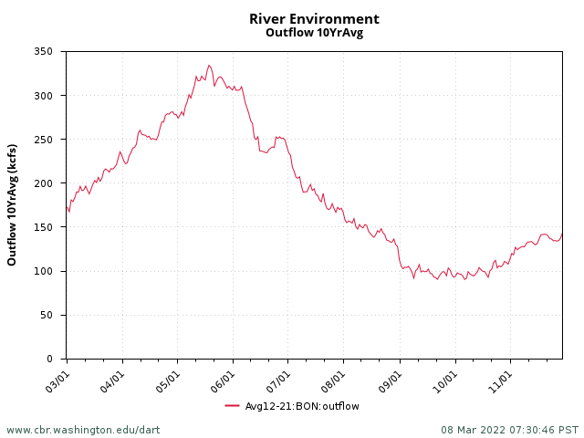

**Figure 1.** 10-year average outflow data during fish passage season at Bonneville. (Obtained from Columbia Basin Research, DART)  
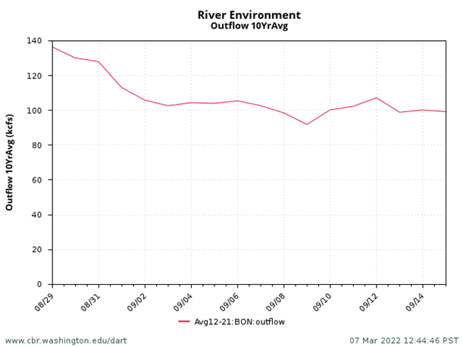

**Figure 2.** Detailed 10-year average outflow data for Bonneville during the planned dates of the T12 outage. (Obtained from Columbia Basin Research, DART)  
  
**Analysis of potential impacts to fish**1. 10-year average passage by run during the period of impact for adults and juvenile listed species, as appropriate for the proposed action and time of year:  
  
2021 fish passage and 10-year average fish passage data (Obtained from Columbia Basin Research, DART):

**Table 1.** Chinook, Jack Chinook, and Steelhead 2021 passage and 10-year average passage data.

**Table 2.** Sockeye, Coho, and Jack Coho 2021 passage and 10-year passage data.  
**Table 3.** Sub-yearling Chinook 2021 passage and 10-year passage data. *Note: This is a passage index dataset derived by the Smolt Monitoring program.*

1. Statement about the current year’s run (e.g., higher or lower than 10-year average):

**Table 4.** Forecasted run predictions obtained from WDFW.

|  |  |
| --- | --- |
| Fall Chinook | Similar to last year |
| Sockeye | Below 10-year average |
| Coho | Above 10-year average |
| Steelhead | Below 10-year average |

1. Estimated exposure to impact by species and age class (i.e., number or percentage of run exposed to an impact by the action):

**Table 5.** 10-year average totals for the timeframe of outage vs 10-year average run totals. (Obtained from Columbia Basin Research, DART)

|  |  |  |  |
| --- | --- | --- | --- |
|  | 08/29 - 09/15 10-Year Average | 10-Year Total Run Average | Percentage of Run Affected |
| Fall Chinook | 291724 | 508512 | 57.4% |
| Fall Jack Chinook | 34967 | 73768 | 47.4% |
| Steelhead | 36103 | 173872 | 20.8% |
| Sockeye | 16 | 300662 | 0% |
| Coho | 38754 | 103212 | 37.5% |
| Jack Coho | 3211 | 10209 | 31.4% |
| Lamprey | 1142 | 35458 | 3.2% |
| Shad | 102 | 4041273 | 0% |
| Sub-Yearling Chinook | 7625 | 3923838 | 0% |

1. Type of impact by species and age class (increased delay, exposure to predation, exposure to a route of higher injury/mortality rate, exposure to higher TDG, etc.):

With Unit 18 OOS, there will be no unit attraction flow for the north entrances of the Washington Shore Fishway, increasing the difficulty for fish to locate the north entrances. However, Fish Unit 1 and Fish Unit 2 will remain in service during this outage and will create appropriate fish ladder entrance differentials according to FPP criteria (BON 2.4.2.4) at each Washington Shore Fishway entrance.

Upstream migrating fish may be more attracted to the south entrances of the Washington Shore Fishway as well as the Cascades Island Fishway and Bradford Island Fishway. Fish that are delayed in finding the north monolith entrances may be at an increased risk of sea lion predation. USDA Hazers are on project hazing during this outage and will be actively hazing pinnipeds in the tailraces during the daylight hours as per FPP 2022 Appendix L.

With Units 15-18 OOS, the submersible traveling screens (STSs) will be also non-operational during this outage, possibly delaying downstream migration. This delay could leave juvenile fish more vulnerable to avian predators in the PH2 forebay. However, the Ice and Trash Sluiceway (ITS) at PH1 will still be operational during this period for downstream passage.

**Summary statement - expected impacts on:**

**Downstream migrants:** Very minimal. Only sub-yearling Chinook were included in the data analysis tables for this operation because all other species and age-classes for downstream migration daily totals were near or at 0 fish per day. This operation is expected to impact near 0% of the downstream sub-yearling Chinook migration. (**Table 5**)

**Upstream migrants (including Bull Trout):** The impact is expected to be greatest on the upstream migration of fall Chinook and fall jack-Chinook. However, all Bonneville Lock & Dam fishway ladders are scheduled to be be fully operational during this time. (**Table 5**)

**Lamprey:** Minimal. Only about 3% of lamprey migration traditionally occurs during the timeframe of this outage (**Table 5**). Therefore, we expect minimal effect on their migration. All Lamprey Passage Structures (LPS) systems will be fully functional at this time, supporting the majority of lamprey passage.

**Comments from agencies**

**CTUIR –**

-----Original Message-----  
From: Tom Lorz <lort@critfc.org>   
Sent: Thursday, March 10, 2022 8:38 AM  
To: Mackey, Tammy M CIV USARMY CENWP (USA) <Tammy.M.Mackey@usace.army.mil>  
Subject: [URL Verdict: Neutral][Non-DoD Source] Re: FPOM: Official Coordination 22BON004 MOC T12 OOS

lets talk about at FPOM. Are they going to do the other line (t11) for the other units after this is done, if so maybe flip flop, I like having 18 on rather than 11 when we have the large push of fall chinook coming through. IF they only doing one line push back about a week to miss the peak of the fall chinook runs would seem like a good idea unless we think we are going to go into split flows which is why they are doing it this way I assume since they think we will be in split flows anyways?

thanks

tom

**10 March FPOM –** 22BON004 MOC T12 OOS. Bettin mentioned there may be a need for a T11 outage in June/July. FPOM will look at the MOC and provide written comments. Conder, Lorz, and Bettin discussed the timing and risks with the proposed schedule. In the end, NOAA, Lorz, and BPA concurred with the MOC. The State’s will provide comments later. **ACTION:** FPOM will need to re-examine the language in the FPP that would require T12 outages to occur during the spring freshet. This increases the risk of PH1 operation and increased fallback with the levels of spill typically seen during the spring.

**Final coordination results**

**After Action update**

Please email or call with questions or concerns.

Thank you,

Tammy Mackey

Columbia River Coordinator - Acting

[Tammy.M.Mackey@usace.army.mil](mailto:Tammy.M.Mackey@usace.army.mil)